**Fig. 13** Calculation time comparison.

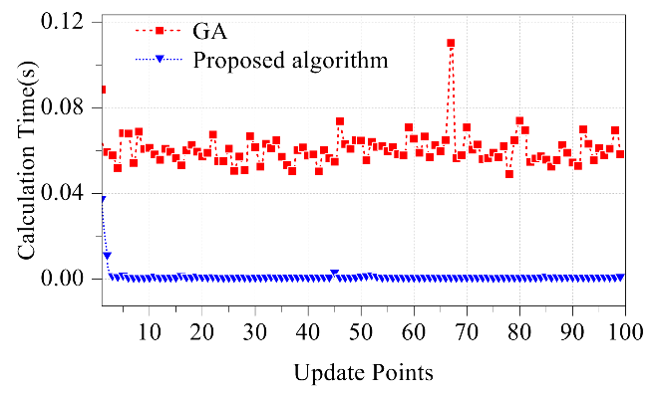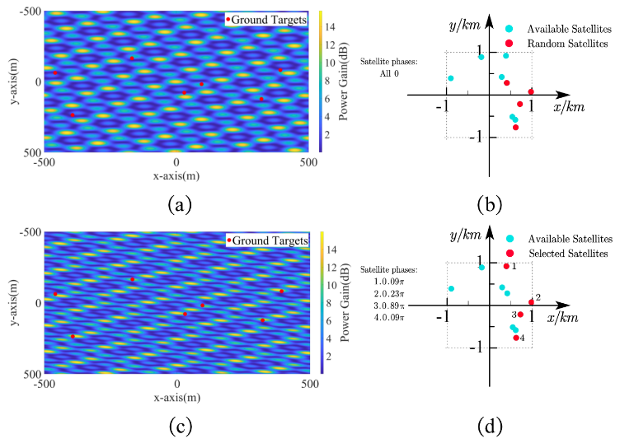

Fig. 10. Results of GA optimization

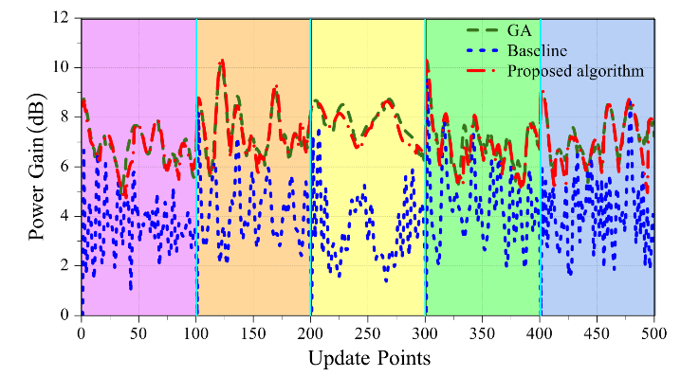

**Fig. 16** Power gain throughout the process of satellite reselections..

**Fig. 11** The power gain of nodes on every update point. (a) the case without optimization and (b) the optimized case.

1. No optimization case

(b)Optimized case

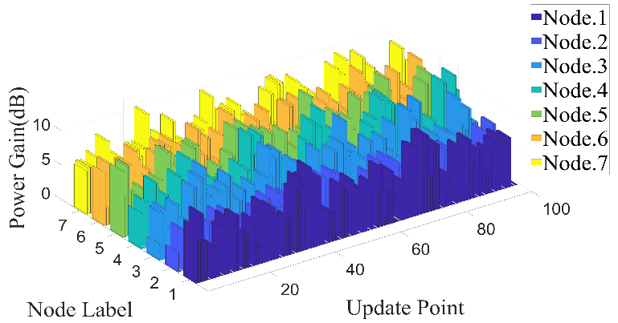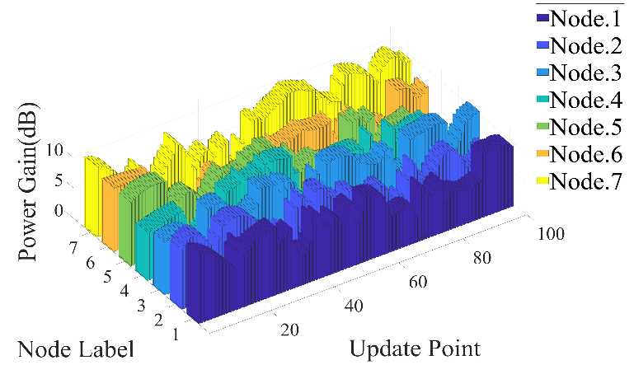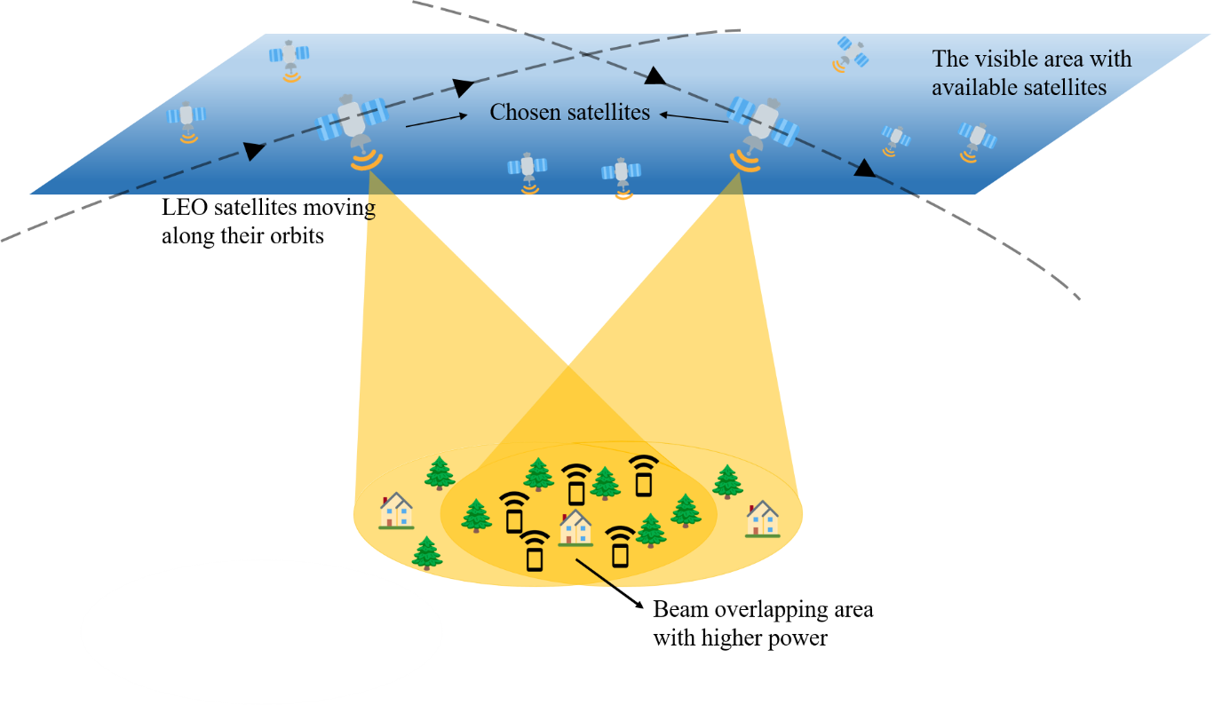

Fig. 1 An illustration of satellite distributed beamforming.

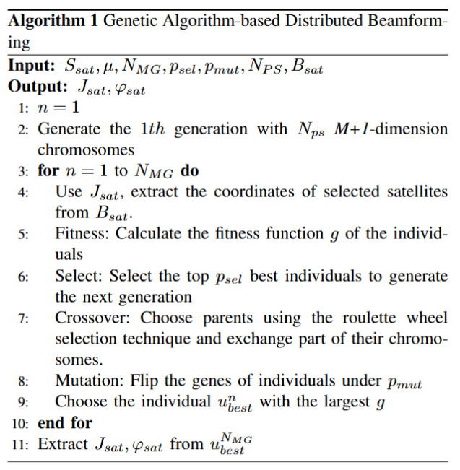

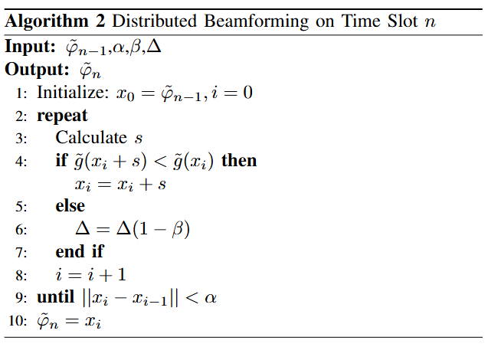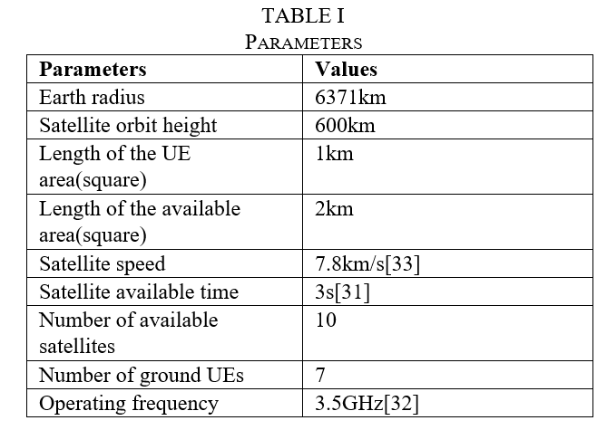

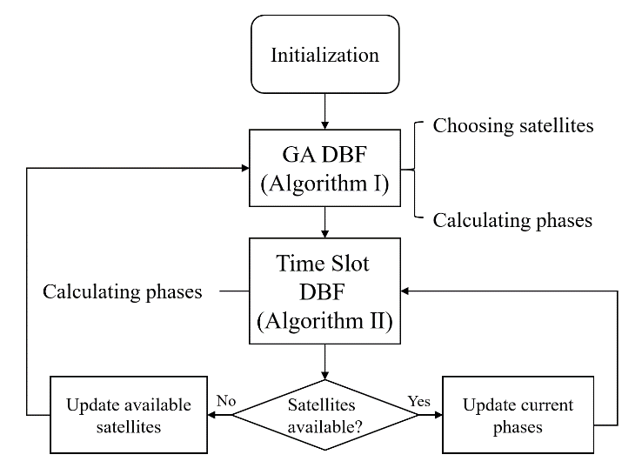

Fig. 7. Algorithm flowchart.

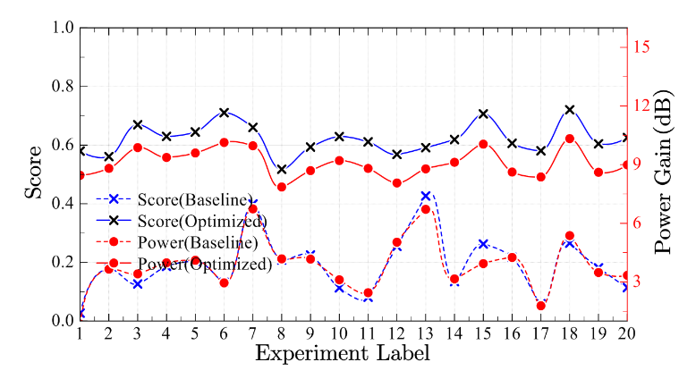

Fig. 9. Results of 20 experiments. The score is calculated according to.

TABLE I

Parameters

|  |  |
| --- | --- |
| **Parameters** | **Values** |
| Earth radius | 6371km |
| Satellite orbit height | 600km |
| Length of the UE area(square) | 1km |
| Length of the available area(square) | 2km |
| Satellite speed | 7.8km/s[33] |
| Satellite available time | 3s[31] |
| Number of available satellites | 10 |
| Number of ground UEs | 7 |
| Operating frequency | 3.5GHz[32] |

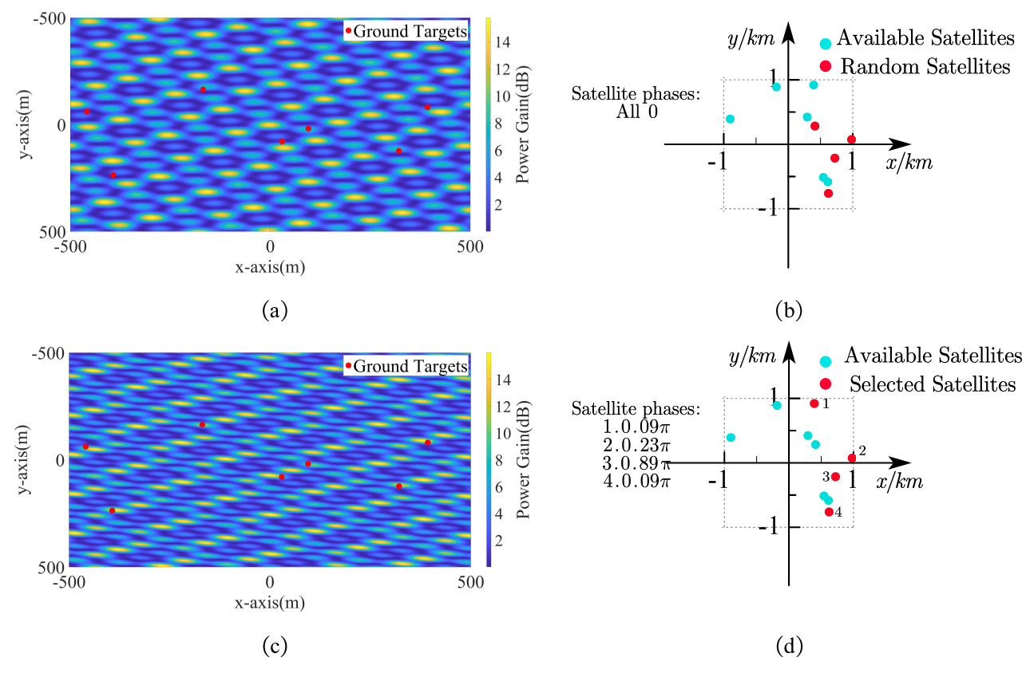

**Fig. 10** Results of GA optimization

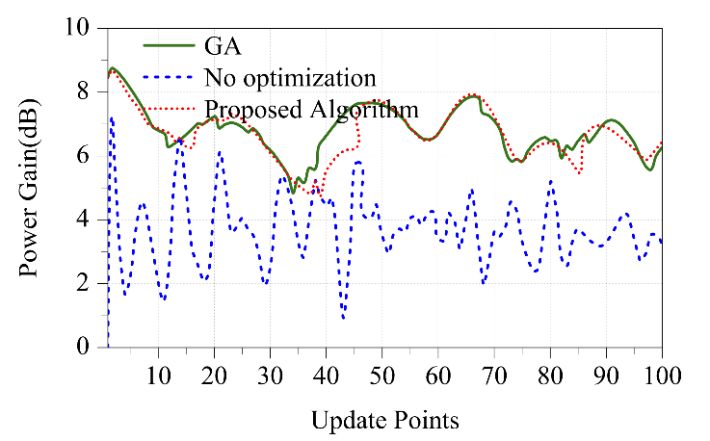

1. Powe gain

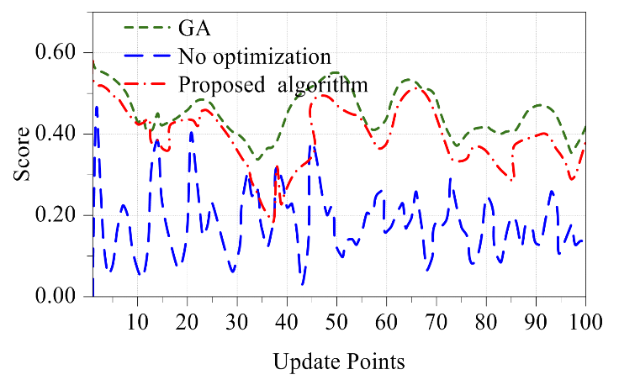

**(b)** Score

**Fig. 12** Power gain and score on each update point.(a) The power gain and (b) the score

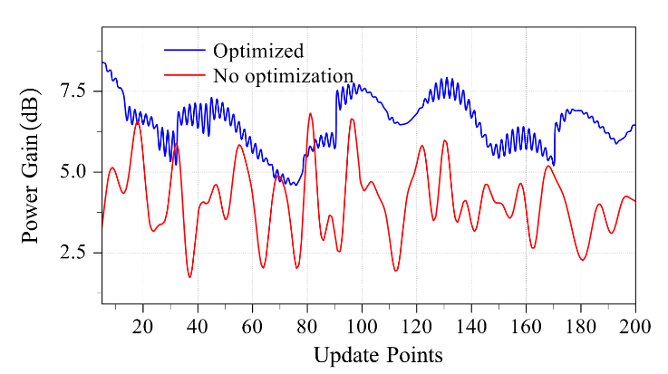

**Fig. 15** Power gain condition between and on each update point.



**Fig. 9** Results of 20 experiments

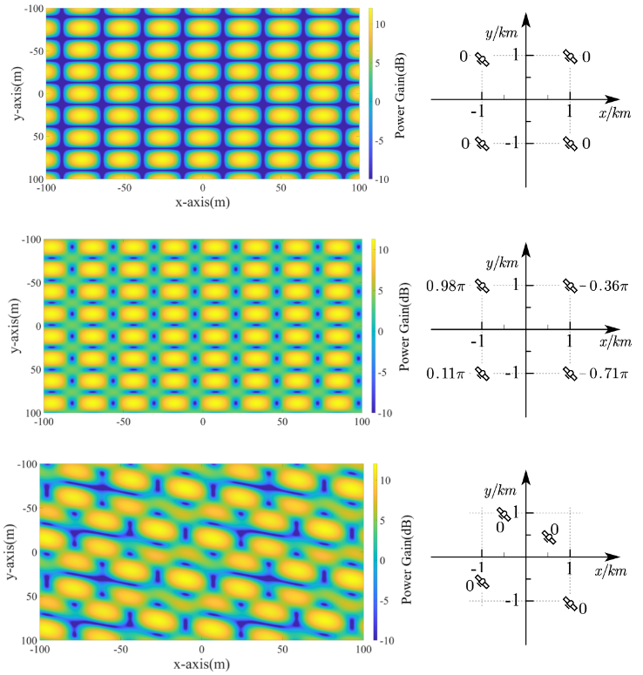

Fig. 8. Factors influencing ground power distribution.

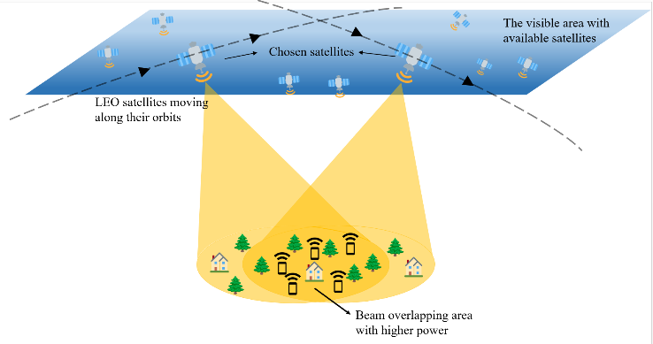

Fig. 1 An illustration of satellite distributed beamforming.

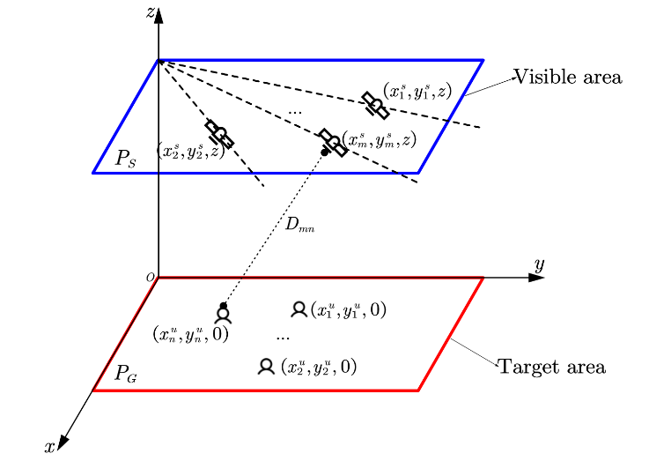

Fig. 2 The mathematical system model



**Fig. 9.** Results of 20 experiments. The score is calculated according to (14).

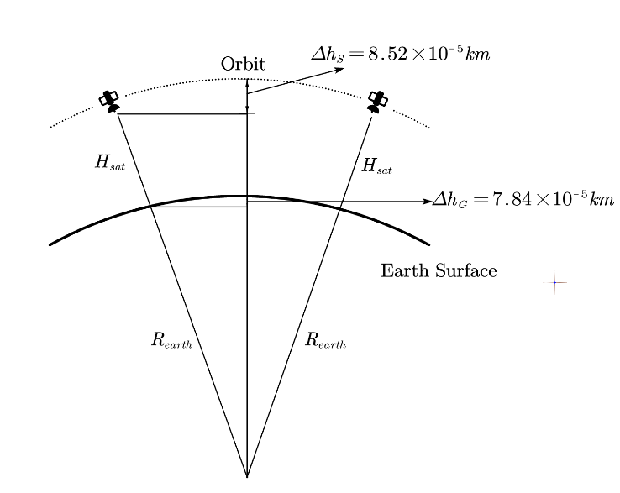

Fig. 3 The original model

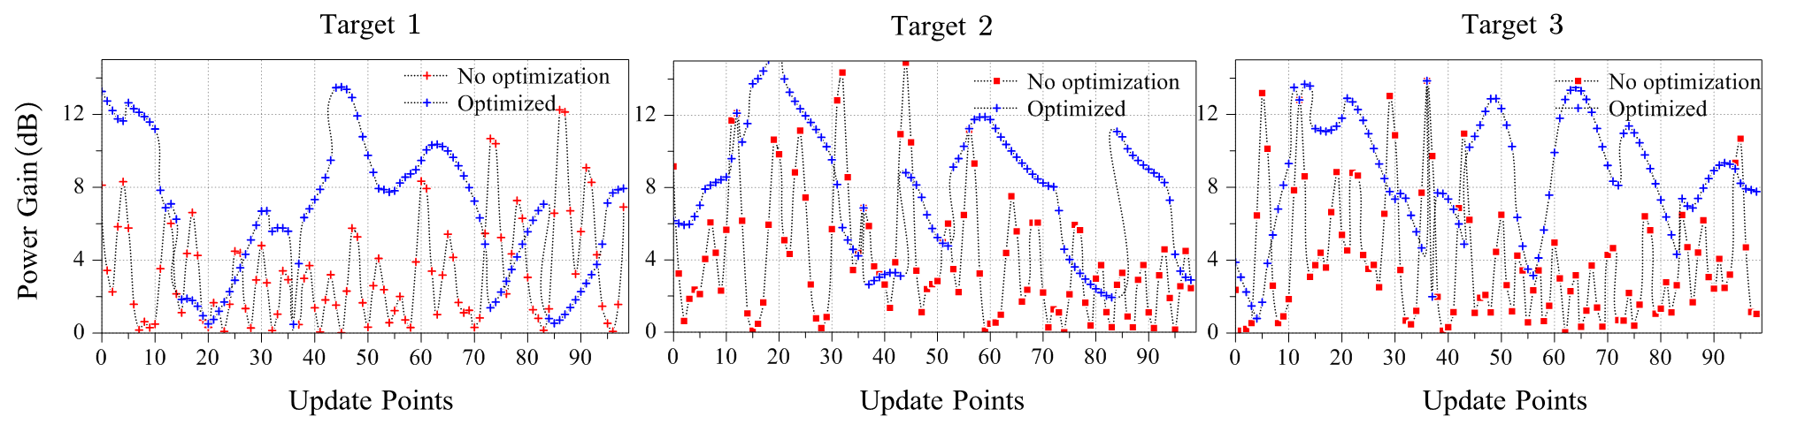

Fig. 14. Power gain of different ground targets.

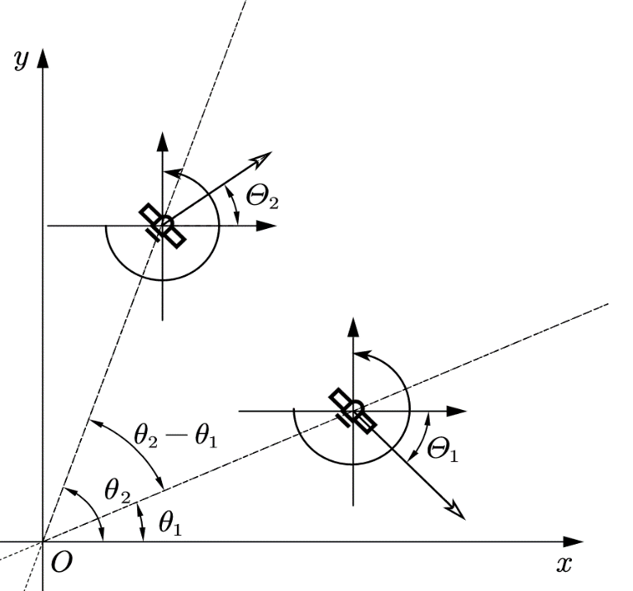

**Fig. 5** The relationship between circular polarization and satellite tracks

(a)

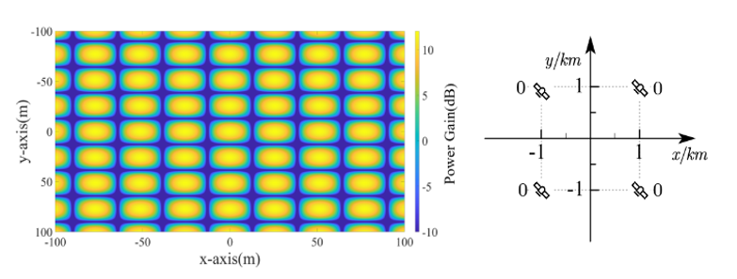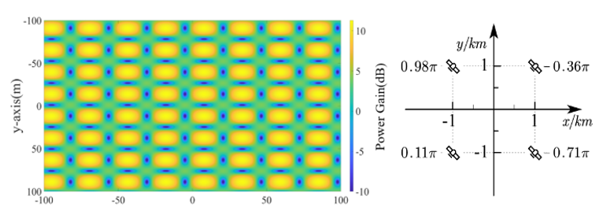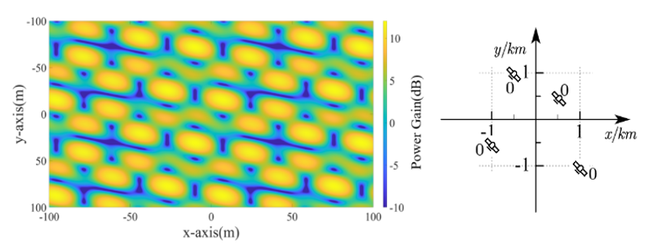

(c)

(e)

(b)

(d)

(f)

Fig. 8**.** Factors influencing ground power distribution.

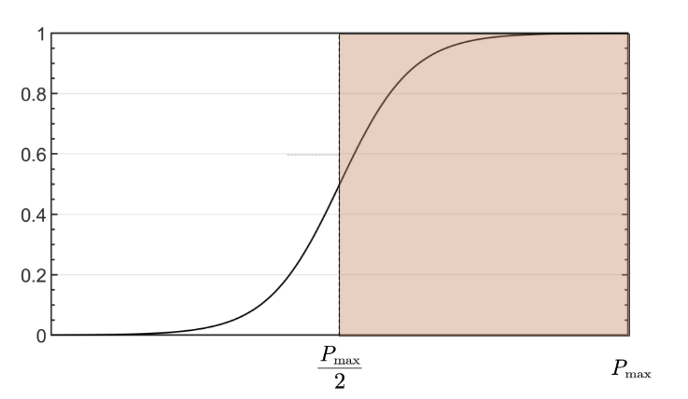

Fig. 6. The graph of *f(x).*

*f(x)*

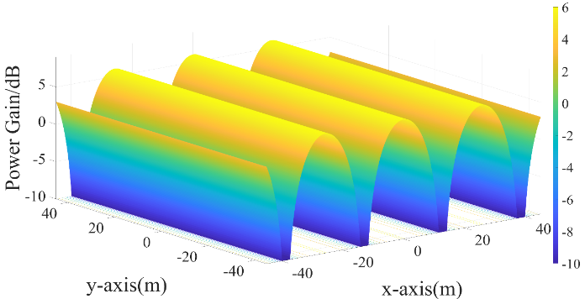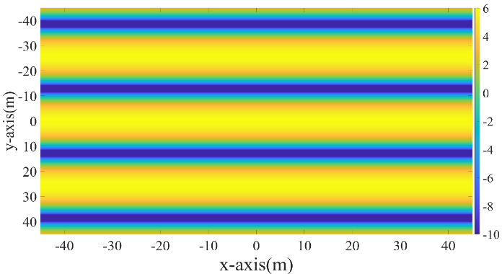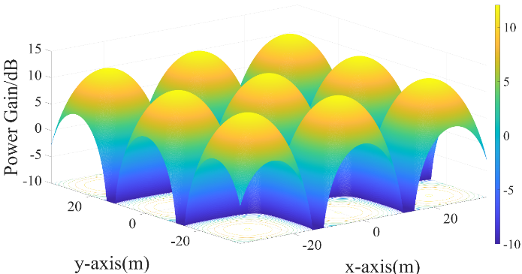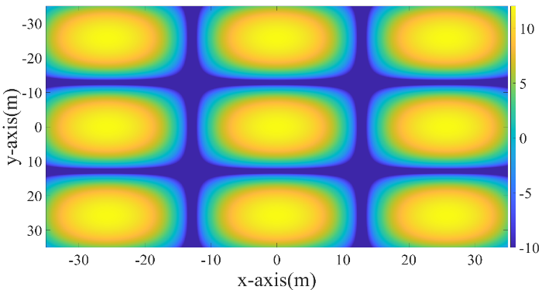

**Fig. 4.** Power gain distribution with fringes and spots.

(c)

(a)

Power Gain(dB)

Power Gain(dB)

Power Gain(dB)

Power Gain(dB)

(b)

(d)